**Software Requirements and Design Document**

**For**

**Group 4**

Version 1.0

**Authors**:

Andrew F

Bret S

William H

William S

# Overview (5 points)

Originally when we were envisioning our game we were thinking a top-down shooter similar to the existing related projects listed in our project proposal (Hotline Miami, Binding of Isaac, etc.), but as none of the four members in our group had experience working with Unity this proposal was more daydreaming than actual forethought into how to implement this idea. Once we did begin working we changed direction rather quickly to something more akin to the Mega Man games for the Nintendo Entertainment System, that is a side scrolling shooter. Our project is still pretty bare bones, but we’ve managed to go from zero collective experience with unity to a nice foundation. So far we have the player character (called Megabot in the files as that’s what the original art asset was named that we got off of OpenGameArt) able to move, jump and shoot as well as a single enemy that has health implemented (you’re not able to see the enemy’s health, but he takes a couple of shots to kill). Our stage is simple a flat plain for now with a parallax scrolling background, but we plan on fleshing out actual levels, platforms, and obstacles during the second iteration.

# Functional Requirements (10 points)

1. Platforms/terrain to jump and place enemies on to add challenge.
2. Implement other enemy types.
3. Implement player health.
4. Implement a user interface (health, current weapon selected).
5. Implement other optional weapon pickups.

# Non-functional Requirements (10 points)

1. Camera shake when player is moving horizontally.
2. Issue with choppy foreground parallax scrolling when moving horizontally.

# Use Case Diagram (10 points)

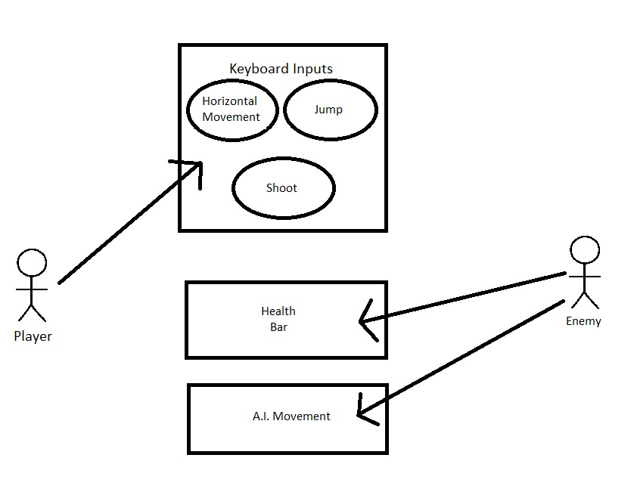

# Class Diagram and/or Sequence Diagrams (15 points)

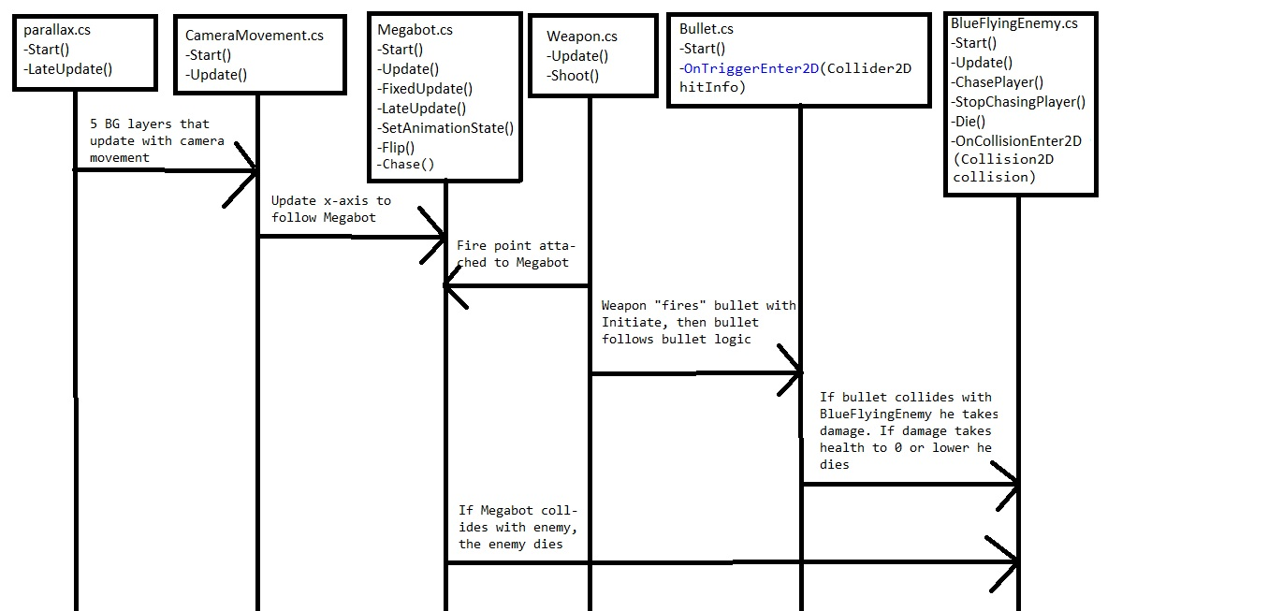

# Operating Environment (5 points)

Software was created with and will operate in Unity version 2020.3.20f1 and Microsoft Visual Studio Community 2019 version 4.8.04084.

# Assumptions and Dependencies (5 points)

Currently there are no dependencies, all information needed to properly run the software is contained in the GitHub repo. If this changes for future iterations we will be sure to update.